Fig. S1.
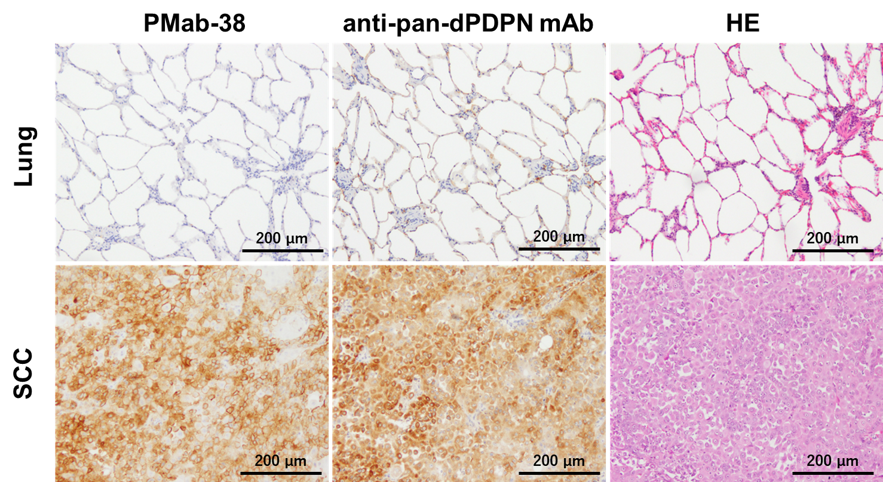

Fig. S2.
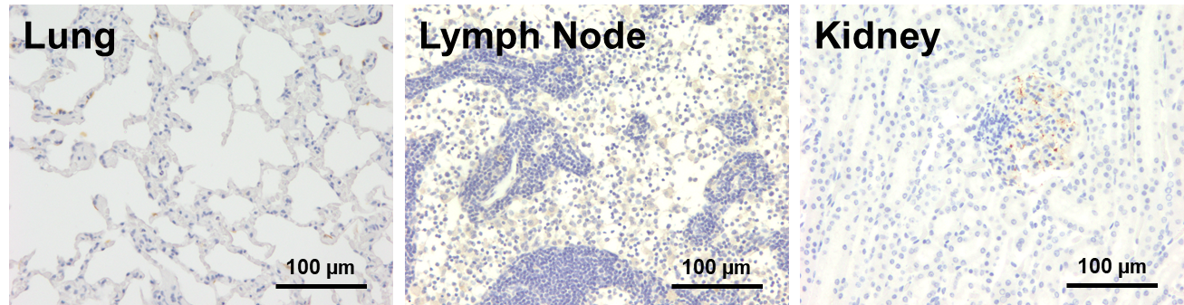

Figure Legends
Supplementary Figure 1. Comparison of staining pattern with PMab-38 and anti-pan-dPDPN mAb. Representative staining patterns of PMab-38 and anti-pan-dPDPN mAb, PMab-48, in normal lung and SCC tissues were shown. Pulmonary type I alveolar cells were stained by PMab-48, but not by PMab-38. Tumor cells of SCC were equivalently stained by both PMab-38 and PMab-48.

Supplementary Figure 2. Evaluation of PMab-38 staining in normal lung, lymph node, and kidney tissues.
Lung and lymph node, which were reported to express PDPN, were negatively stained by PMab-38. Although the intensity was weaker than SCC, part of the normal glomerulus in the kidney was positively stained by PMab-38 (see also Fig. 3).

